Summery

There are total of 12000 users sing up for the product from 2012 to 2014 in the give time period. There is a significant increase in 2013 and remarkable decrease in 2014. The correlation with such changes will be communicated.

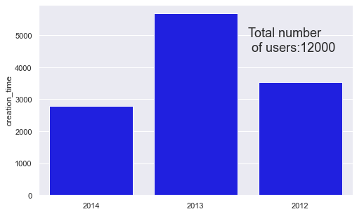**Users who signed up for the product in the last two years**

In 2013, almost in ever category it doubles the previous years of number of users.  
As it can be seen from the graph below, there is high number of users when they are invited to an organization (as a full member).  
Other factor are have similar characteristics other then google email auth . sign ups.

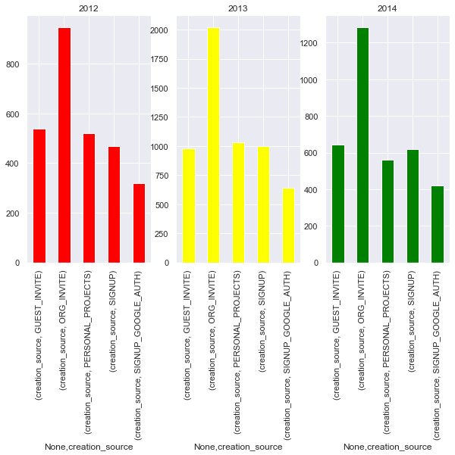

There are 3177 of 1200 signed up however they have never created a session. These users will be dropped to clean the data. This is about 27% of the data.  
  
Number of user invited to join by their friends is 6417 which is about 53% of the data. This shows that word of the mouth is very important.

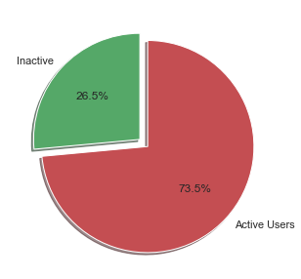

As it is defined in the instructions, defining an "adopted user" as a user who has logged into the product on three separate days in at least one seven days period , identify which factors predict future user adoption.

There are total 207917 logins, Number of logins in 7 consecutive days are gathered. After cleaning the duplicates and there are only 1602 unique members who visited more than 3 times in a week.

|  |  |  |  |  |
| --- | --- | --- | --- | --- |
|  | **time_stamp** | **user_id** | **visited** | **visits_7_days** |
| 0 | 2014-04-22 03:53:30 | 1 | 1 | 1.0 |
| 1 | 2013-11-15 03:45:04 | 2 | 1 | 1.0 |
| 2 | 2013-11-29 03:45:04 | 2 | 1 | 1.0 |
| 3 | 2013-12-09 03:45:04 | 2 | 1 | 1.0 |
| 4 | 2013-12-25 03:45:04 | 2 | 1 | 1.0 |